Lab Assignment 6 - Complex SELECT statements

## Instructions

1. Answer the below question in the boxes.
2. Please submit the assignment through TalentLabs Learning System.

## Open the Movies database

Follow the step illustrated in Chapter 3 to open the Movies database using DB Browser for SQLite. You should see 5 tables in the database.

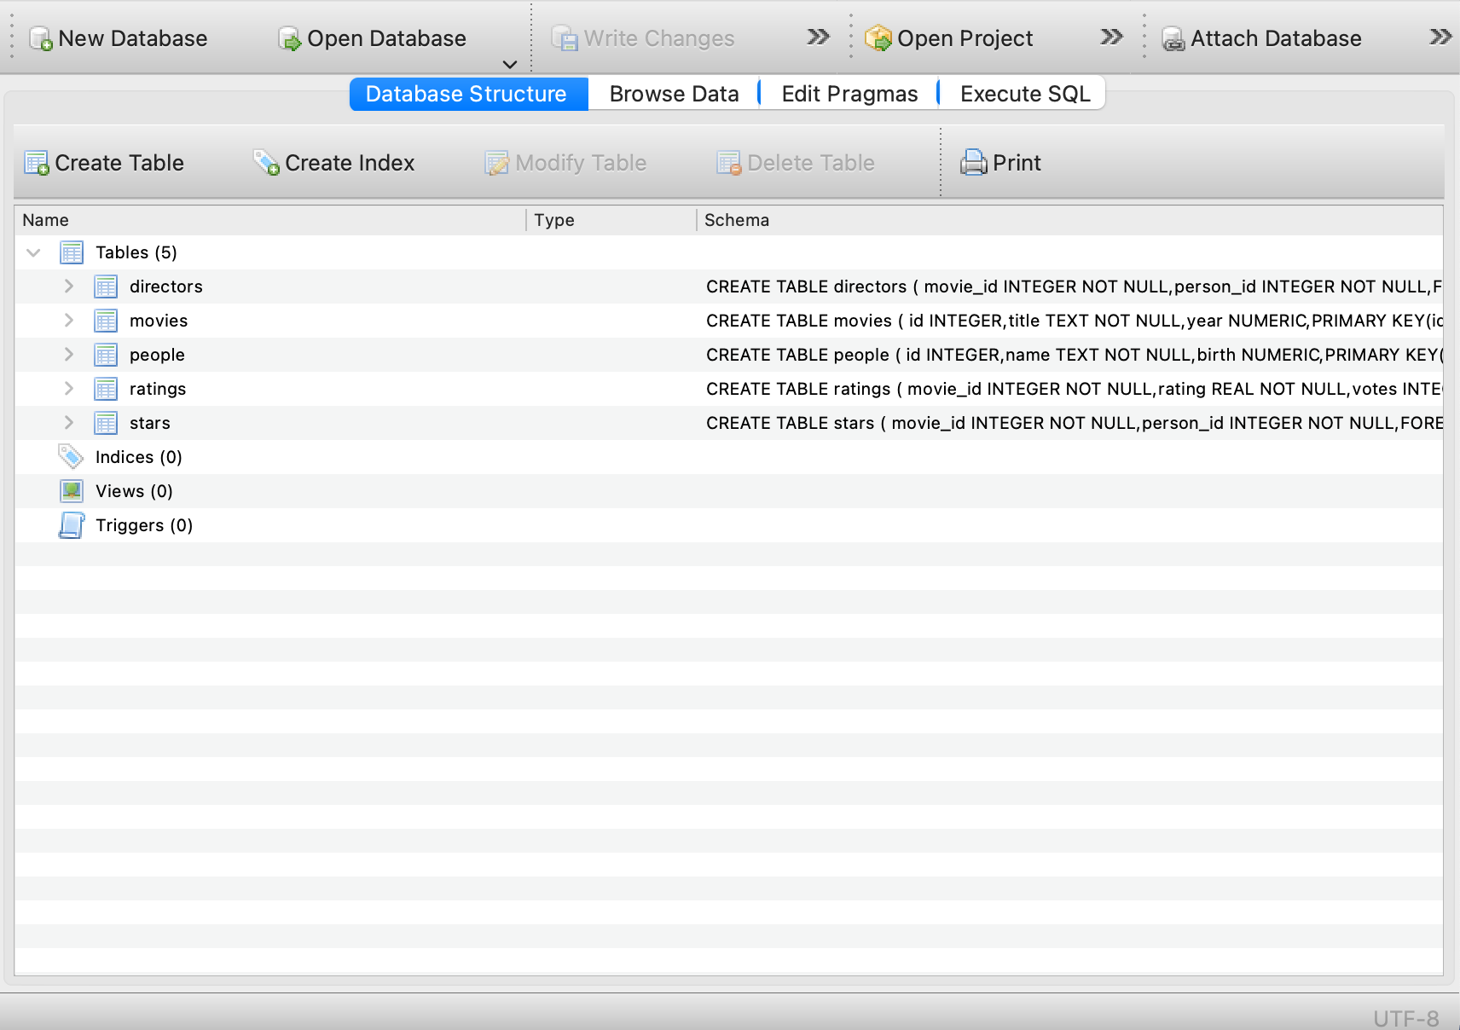

## 

## Understanding the database

1. Study the table schema and the data in the “people” and “directors” table and describe the relation between the tables “people” and “directors”

|  |
| --- |
| **“people”** table consists of “id”, “name” and “birth”, while **“directors”** table consists of “movie_id” and “person_id”.  The ***“person_id”*** in ***“directors”*** table corresponds to ***“id”*** in ***“people”*** table |

1. Study the table schema and the data in the “movies” and “directors” table and describe the relation between the tables “movies” and “directors”

|  |
| --- |
| **“movies”** table consists of “id”, “title” and “year”, while **“directors”** table consists of “movie_id” and “person_id”.  The ***“movie_id”*** in ***“directors”*** table corresponds to ***“id”*** in ***“movies”*** table |

## Query Exercises

1. Write a SQL query to obtain the movie_id who is directed by “Joris Ivens” without using WITH keyword

**Expected Output:** a table with a single column for the movie_id of the director’s movie.

|  |
| --- |
| SELECT movie_id  FROM directors  WHERE person_id IN (  SELECT id  FROM people  WHERE name LIKE 'Joris Ivens'  ) |

1. Write a SQL query to obtain the movie title who is directed by “Joris Ivens”  
   **Expected Output:** a table with a single column for the movie title of the director’s movie.

|  |
| --- |
| SELECT title  FROM movies  WHERE id IN (  SELECT movie_id  FROM directors  WHERE person_id IN (  SELECT id  FROM people  WHERE name LIKE 'Joris Ivens')  ) |

1. Organize and rewrite the SQL query of Q1 using WITH keyword  
   **Expected Output:** The SQL query in WITH keyword

|  |
| --- |
| WITH joris_id AS (  SELECT id  FROM people  WHERE name LIKE 'Joris Ivens'  )  SELECT movie_id  FROM directors  WHERE person_id IN (  SELECT id  FROM joris_id  ) |

1. Write a SQL query to show each person’s name and whether the person is born before 1970, born in 1970, born after 1970  
   **Expected Output:** The SQL query fulfilling the required data

|  |
| --- |
| SELECT name,  CASE  WHEN birth < 1970 THEN 'born before 1970'  WHEN birth = 1970 THEN 'born in 1970'  WHEN birth > 1970 THEN 'born after 1970'  END AS birth_period  FROM people |

1. Write a SQL query to count the number of people in the “people” table by each birth year.  
   **Expected Output:** The SQL query fulfilling the required data. Note that having the NULL birth year on the query result is normal.

|  |
| --- |
| SELECT birth AS year,  COUNT(birth) AS number_of_people  FROM people  GROUP BY birth |

1. Write a SQL query to count the number of directors by each birth year. Only the years with more than 500 directors born are interested.  
   **Expected Output:** a table with two columns for the birth year and count of directors.

|  |
| --- |
| SELECT birth AS birth_year, COUNT(id) AS count_of_directors  FROM people  WHERE id IN (  SELECT person_id FROM directors)  GROUP BY birth  HAVING COUNT(id) > 500 |

**- End of Assignment -**